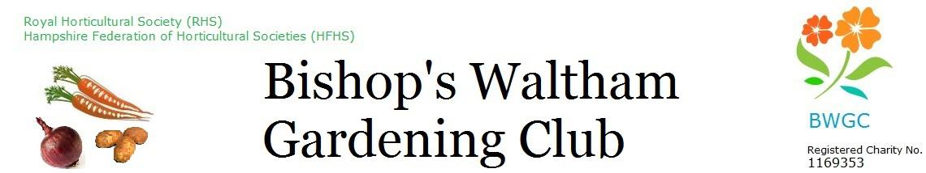
Minutes

Date: Monday 18 August 2025 at The Shed
Time: 7:30 pm

Present: Dave Bennett (DCB) Chair, Maewyn Cumming (minutes) (MC), Linda Haysom (LH), Ron Haysom (RH), (AP), Gill Hamill (GH), Larry Mabey (LM), Robin Breach (RB), Kate Cassell (KC), Neal Davies (ND), Gill Williams (GW), David Bushby (DB)

Item | Minutes | Actions
- Apologies for absence | Alison Perry
- Minutes of previous meeting | Item 16 change LH to LM
- Actions list – Outstanding Actions from June Meeting | - DCB to approach PC about container on site – to do.  - MC to contact SH re Instagram account
- Finance | See LH’s finance papers.  £28,534.39 total in bank  Budget setting for 25/26 – each budget holder to review and either bid for more or reduce.  The show made a profit of £383, though there may be more invoices to come.  Lloyds will soon start charging a monthly fee so LH will investigate alternative banking arrangements. | - ALL – Get outstanding invoices in asap.  - ALL – each budget holder to review budget and make decision as to whether need more or less for next year.  - LH investigate alternative banking arrangements
- Trustees | The Chair welcomed back David Bushby as a trustee.  Anthea Mabey, handed in her notice as a trustee, Trustees send their thanks for all her work over the last years
- Membership | We have 367 members, including 174 plot holders. Numbers are steadily increasing.  John Price to be made an honorary member, in recognition of his long service to the Club and the community. | MC – approach John Price re honorary membership
- Trading | Relatively quiet. Seed potatoes and onion sets for next year will soon arrive.
- Allotments - maintenance | Gates damaged by vandals will be left as they are, they are still operational. Deer are still getting in, it is uncertain where.  Payback came in – cleared fenceline.  Water butt has been cleaned and open for use.  Formal thanks were given to LM for all of the work he has done on maintenance over the past years.  A member is concerned about the cleanliness of the handles on the gates, and has agree to routinely clean them.
- Allotments | Allotment rules to be displayed in the Shop.  Draft tenancy agreement discussed. | - All – send comments on draft tenancy agreement to MC  - MC – update and distribute draft tenancy agreement
- Monthly programme | Speakers are still being sought for November.  Prizes for member’s show to be organised. | - MC – arrange prizes for members show
- Social programme | Social – 10/10/25 – tickets ready to be printed. There is some doubt about the viability of the Ghost Kitchen, this will be checked. | - LH/GW begin publicity for Social.
- Annual Show | The Show was a great success, and the trustees thanked the organisers for doing such a fine job. The number of attendees and entries was well up on previous years. Although it was not an objective, it was good to note a small profit was made (final figures still to be determined). Thanks were offered to Russell Masters, Amy Humphries, Linda Smith, Janice Romer, and Gill Stainer for all of their help with the catering. More help will be needed next year if the number of attendees is the same or more.  The Soberton Strummers and the cake decorating went down very well. Few children attended the show, and there were few entries in the children’s classes.  The trustees were pleased to note that the show committee are prepared to stay for next year. The provisional date is 25 July 2026.
- Update / publicity / social media | An A3 printer would be of value, but only for accessional use so not worth buying. We can perhaps ask the Parish Council.  We have 264 Facebook group members. Not too many posts but lots of people reading the posts.
- Charity programme | St Peters Fayre – Sept, we will offer cress growing. Will need small yoghurt pots or similar.  Student sponsorship – 2 potentials for coming year,  Greening event, Oct 11. We will have a stand. | All – to provide small yoghurt pots for St Peter’s Fayre  MC – ask members for yoghurt pots
- Any other business | Martin Livermore, BW Cricket Club, has asked for our support in turning the dog walking area into a car park. We will support this.  People have been seen taking food from the food bank.  A new Sutton’s code is on the way.  We will consider renaming The Shop.  Complaint – the response to a formal complaint was agreed. | - DCB – respond to Martin re car park  - MC remind members that items in the food bank are not to be taken for other purposes.  - DCB amend and send complaint response.

Meeting finished at 2155

Next meeting: Monday 15 September 2025 at The Shed 7.30pm

Actions
ALL – Get outstanding invoices to in as we get to end of FY.
ALL – each budget holder to review budget and make decision as to whether need more or less for next year.
All – send comments on draft tenancy agreement to MC
All – to provide small yoghurt pots for St Peter’s Fayre
DCB – respond to Martin re car park
DCB amend and send complaint response.
LH investigate alternative banking arrangements
MC – ask members for yoghurt pots
MC – update and distribute draft tenancy agreement
MC – approach John Price re honorary membership
MC – arrange prizes for members show
MC remind members that items in the food bank are not to be taken for other purposes.

